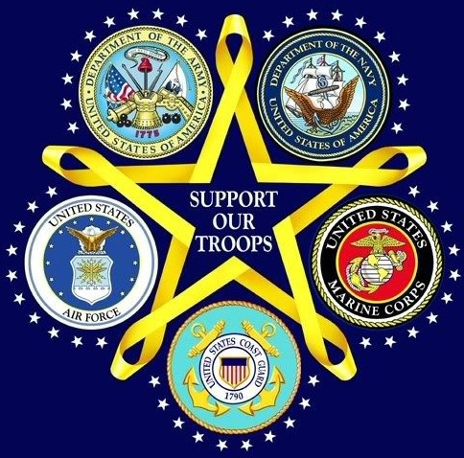
MAY IS NATIONAL MILITARY APPRECIATION MONTH
Come Say Thank You

Come Say Thank You

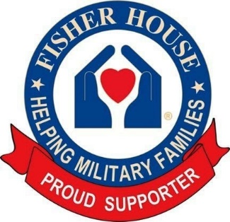
SHOW YOUR GRATITUDE AT OUR “SUNDAY FUNDAY” FUNDRAISER FOR THE FISHER HOUSE FOUNDATION
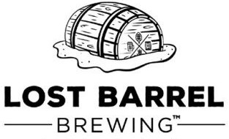

Fisher House provides a ‘home away from home’ for patients receiving medical care at major military and VA medical centers. It’s temporary free lodging so military and Veterans’ families can be close to their loved ones during a medical crisis.
SUNDAY, MAY 22nd FROM NOON TO 4PM
JOIN LOST BARREL BREWING & CRUISIN FOR HEROES
AND PAY TRIBUTE TO THE MEN AND WOMEN OF THE ARMED FORCES
AND HONOR OUR MILITARY HEROES AND THEIR FAMILIES
LOST BARREL BREWING WILL BE DONATING 10% OF BEER SALES TO THE FISHER HOUSE FOUNDATION
CRUISIN FOR HEROES WILL HAVE AN INFORMATION BOOTH AND ITEMS AVAILABLE FOR ADDITIONAL DONATIONS
THIS FAMILY FRIENDLY EVENT IS A COLLABORATION BETWEEN LOST BARREL BREWING (36138 JOHN MOSBY HWY, MIDDLEBURG, VA) AND CRUISING FOR HEROES IN SUPPORT OF OUR MILITARY, ITS VETERANS AND THEIR FAMILIES.

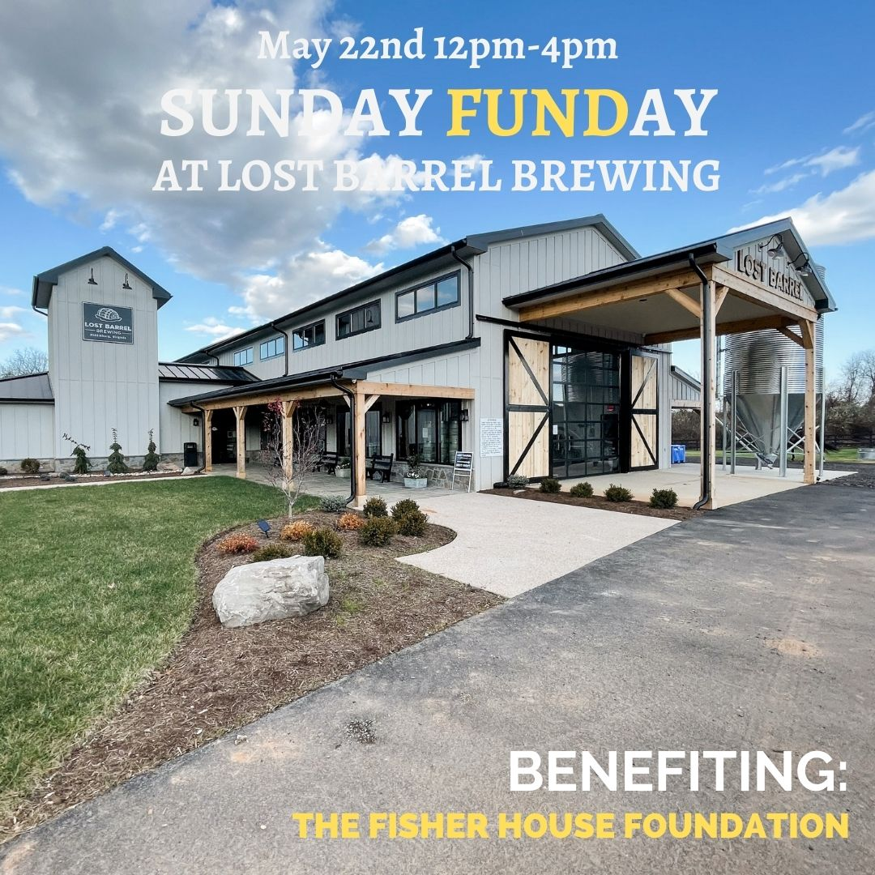
HONOR OUR MILITARY HEROES AND THEIR FAMILIES
Come Say Thank You

