ARMED FORCES DAY GIVE BACK FUNDRAISER FOR
THE FISHER HOUSE FOUNDATION
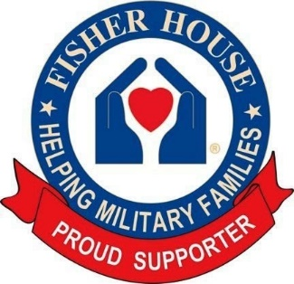
Fisher Houses provide ‘a home away from home’ for families of patients receiving medical care at major military and VA medical centers. The homes provide temporary free lodging so military and Veterans’ families can be close to their loved ones during a medical crisis.
SATURDAY, MAY 16 FROM 10AM TO 2PM
COME JOIN CHILI’S OF CULPEPER (15181 MONTANUS DR.)
AND
PAY TRIBUTE TO THE MEN AND WOMEN OF THE ARMED FORCES
AND
HONOR OUR MILITARY HEROES FOR THEIR PATRIOTIC SERVICE.
CHILI’S WILL BE DONATING A PORTION OF SALES TO THE FISHER HOUSE FOUNDATION
WEATHER PERMITTING, BRING YOU CLASSIC CAR, TRUCK OR MOTORCYCLE AND RECEIVE A GOODY BAG, WHILE SUPPLIES LAST, FOR YOUR PARTICIPATION.
IN ADDITION, CHILI’S GIFT CARDS WILL BE RAFFLED OFF DURING THE EVENT.
THIS EVENT IS A COLLABORATION BETWEEN CHILI’S OF CULPEPER AND CRUISING FOR HEROES IN SUPPORT OF OUR MILITARY, ITS VETERANS AND THEIR FAMILIES.

