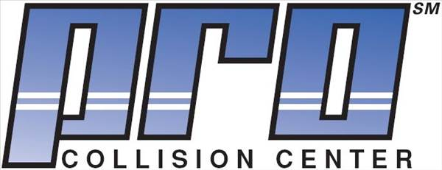
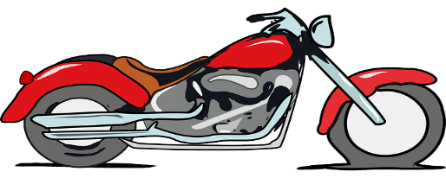

12403 James Madison Highway, Orange, VA 22960
* Pro Collison Center Fundraiser Cruise-In *
Saturday October 3rd 2PM till 6PM
- CDC guidelines in effect at the time will be adhered to
- This is a weather permitting event
Family Friendly Event Supporting Community & Our Military
NATIONAL AUTO BODY COUNCIL
FIRST RESPONDER EMERGENCY EXTRICATION (FREE) DEMONSTRATION
DOOR PRIZES
INCLUDING A FULL AUTO DETAILING VALUED AT $165
JOE JOE’S HERSHEY’S ICE CREAM

MUSIC BY
“DJ” CHIP

50/50 RAFFLE

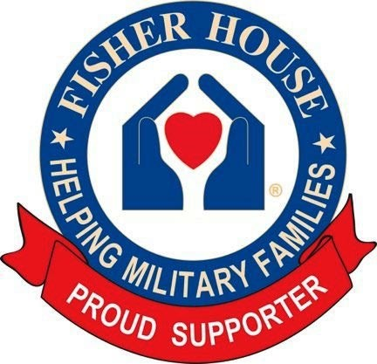
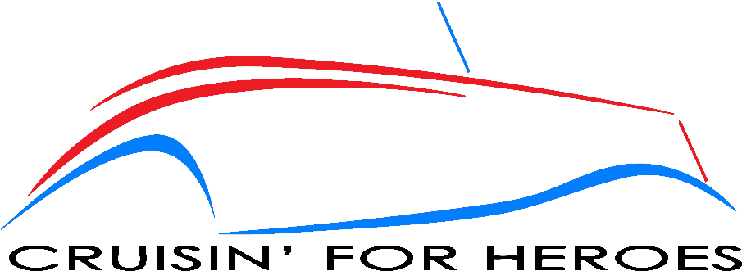
*This is a fundraising event for the Fisher House Foundation which provides a “home away from home” for families of patients receiving medical care at military and VA medical centers. Pro Collision Center is sponsoring this event in collaboration with Cruisin For Heroes and will be making a generous donation to Fisher House.
Note: Acceptance of the right to participate in any Cruisin For Heroes event or display releases and discharges Cruisin For Heroes, its members, staff, volunteers and anyone else connected with the management and presentation of a Cruisin For Heroes event or display of and from any and all known or unknown injuries, losses, judgments, and/or claims connected with the event or display. Cruisin For Heroes events are not entrance fee based nor do they require any booking fee. Cruisin For Heroes does not promote, condone or tolerate any unlawful and/or dangerous driving behavior at an event or when traveling to or from an event.
