CRUISIN FOR HEROES
$ THIS IS A FUNDRAISING ITEM
FOR THE FISHER HOUSE FOUNDATION $
SPECIAL 11oz COFFEE MUG
(WITH TWO-SIDED LOGOS)
MICROWAVE & DISHWASHER SAFE
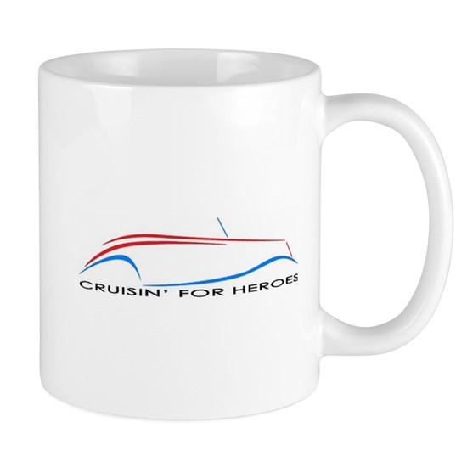
$15 OR 2 FOR $25

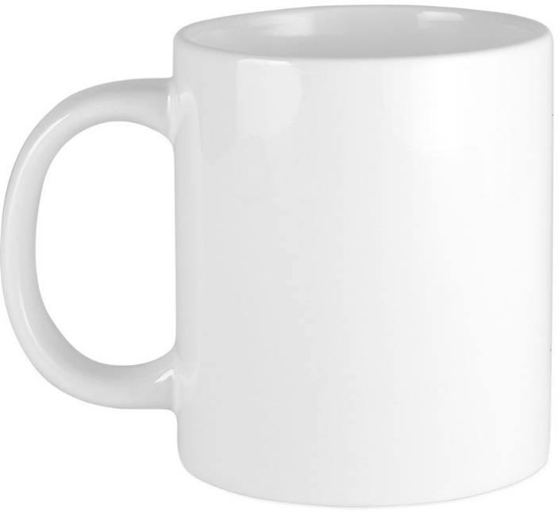
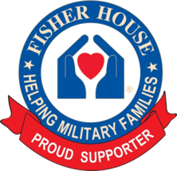

THANK YOU FOR YOUR GENEROSITY

