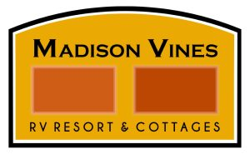

Madison Vines RV Resort & Cottages
110 Campground Lane Madison, VA 22727
*2023 ‘50’s Theme BBQ & Fundraiser*
Saturday July 29th 1PM till 4PM
Family Friendly Event Supporting Community & Our Military
Guests attending this event will also have access to the Resort Pool & Spa for a $5 donation to Fisher House.
“Invitational Classic Vehicle Display”
PROVIDED BY CRUISIN FOR HEROES (WEATHER PERMITTING)
MUSIC BY DJ
“CHIP” HARVEY

50 / 50 RAFFLE AWARDED AT 4PM

*This is a fundraising event for the Fisher House Foundation which provides a “home away from home” for families of patients receiving medical care at military and VA medical centers.
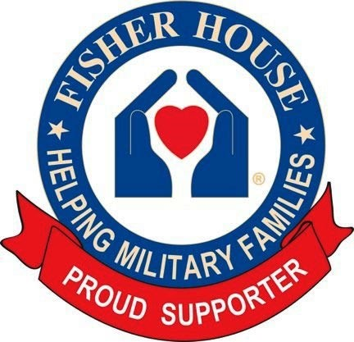
* In addition to all donations collected during this event, Madison Vines RV Resort & Cottages will be making a generous donation to Fisher House. *

Note: Acceptance of the right to participate in any Cruisin For Heroes event or display releases and discharges Cruisin For Heroes, its members, staff, volunteers and anyone else connected with the management and presentation of a Cruisin For Heroes event or display of and from any and all known or unknown injuries, losses, judgments, and/or claims connected with the event or display.

